

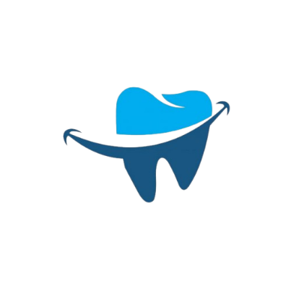
32 Smiles

Faculty: Sir Abdul Basit
Batch: 2024-AI-08C
1st Semester
Group Members:

- Mr. Owais Baig Student1605047

- Mr. Fahad Musa
Student1603843

- Mr. Hassan
Student1603810

- Mr. Mustafa
Student1604199

- Mr. Huzaifa
Student1604198

Project Start Date: 25-Jan-2025
Project End Date: 24-Feb-2025
ACKNOWLEDGEMENT
Our project, 32 Smile, is a website designed to provide comprehensive information about dental care, professional resources, patient education, and the latest research. This website was developed using HTML, CSS, JavaScript, and Bootstrap, ensuring a responsive, structured, and user-friendly experience.
The site includes features such as organized navigation menus, categorized product listings, an educational media library, and an interactive contact section. The use of Bootstrap helped us create a mobile-friendly layout, while JavaScript added interactivity to enhance usability.
This project is a collaborative effort by Fahad, Owais, and Hassan, developed as part of our Software Engineering course at Aptech Institute. The goal was to build a well-structured and visually appealing website that provides users with easy access to valuable dental information.
Developing 32 Smile has been a great learning experience, and we look forward to further improving and expanding its features in the future.

32Smile – Documentation

1. Introduction

1.1 Home Page
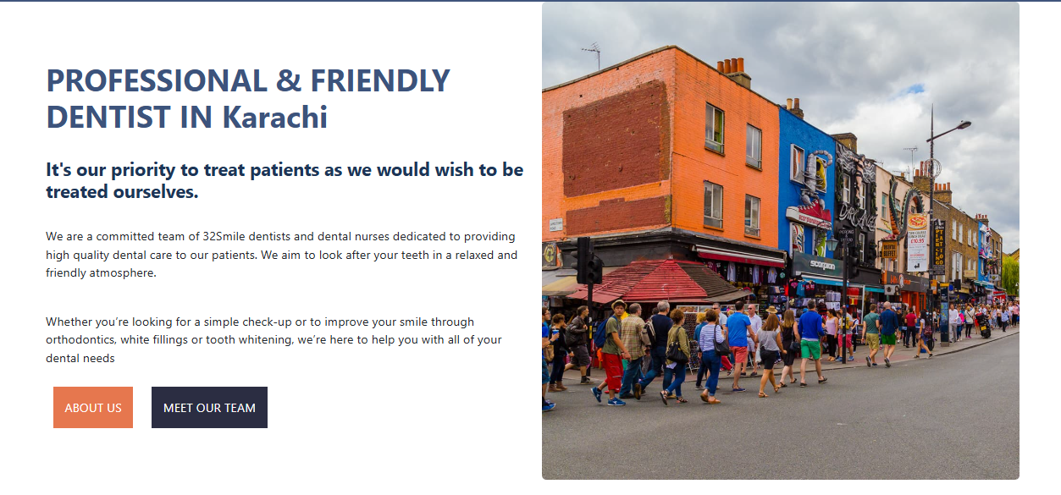
This dental website offers a welcoming and organized user experience, starting with a Topbar and navigation bar for easy access to important sections. It showcases engaging images and content, along with an appointment booking section for convenience. The gallery highlights dental services and treatments in a card layout, while patient reviews build trust and credibility. The footer provides essential contact information and links, ensuring visitors have everything they need for a seamless experience.

1.2 Professional Education
The "Professional Education" dropdown features Courses, Faculty, Case Studies, Help Documents, and Student Resources, all designed to support and enhance your learning journey.

Courses:
The "Courses" section features a diverse selection of dental courses, categorized into Basic, Advanced, and specialized levels, catering to learners at every stage and helping them master essential skills and expertise in dentistry.
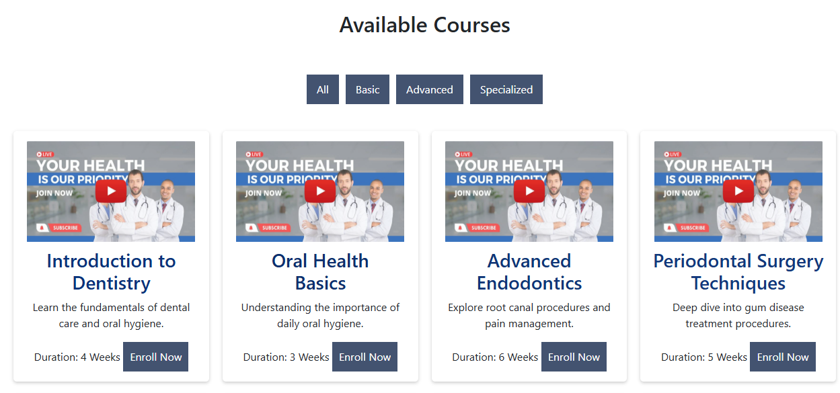

Faculty:
The "Faculty" section highlights a diverse team of experts, including Dentists, Surgeons, Nurses, and Admin staff, each bringing specialized knowledge and experience to provide top-tier education and support within the dental field.
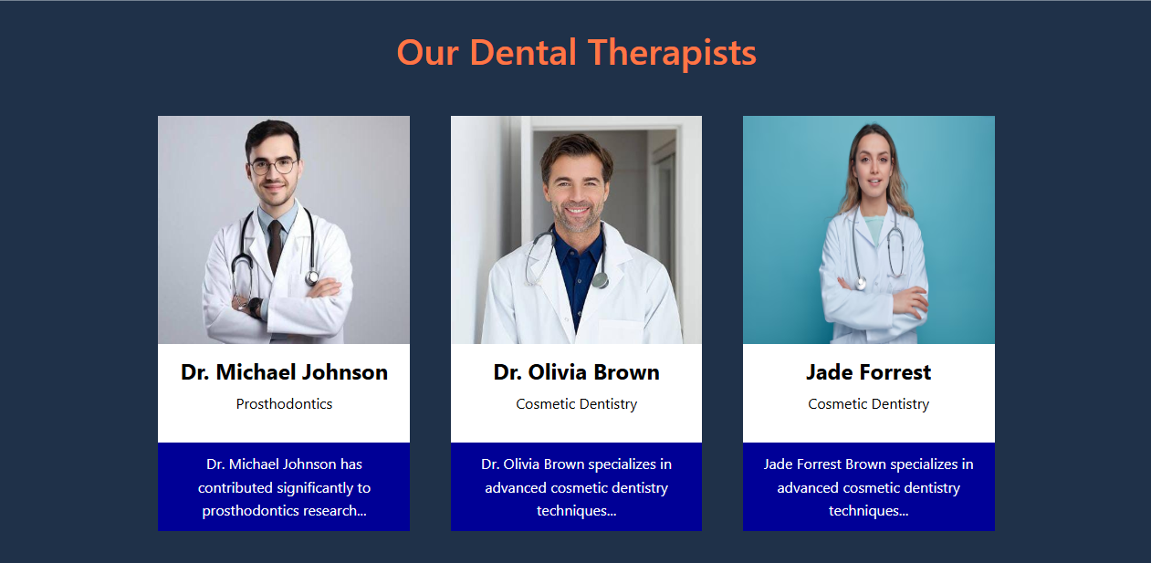

Case Study:
The Case Study page presents six detailed dental cases, each illustrating real-world patient scenarios, diagnoses, treatments, and outcomes. With a structured layout, it provides valuable insights for students and professionals, enhancing their understanding of clinical practices through practical examples.
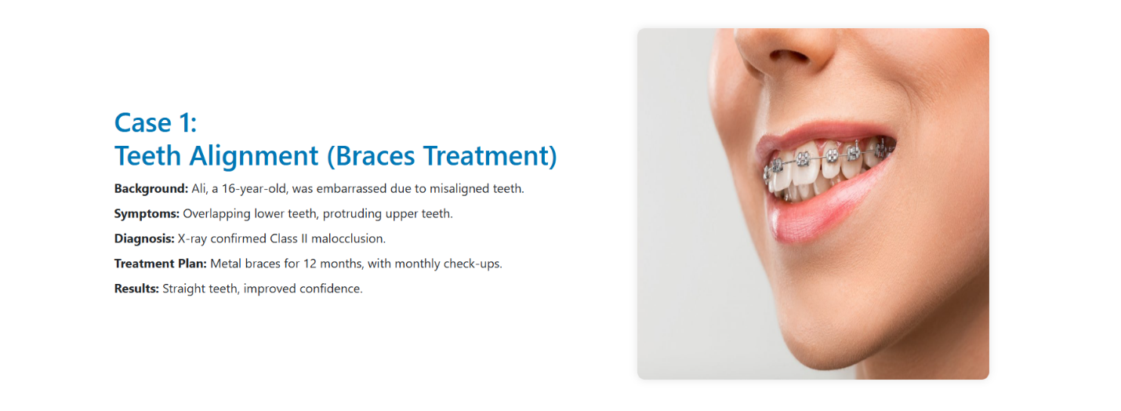
Help Documents:
The Help Documents page serves as a comprehensive resource hub, offering FAQs, downloadable PDFs, and external references to assist students and professionals in their dental studies. With a structured layout, it ensures easy access to essential information, along with a direct link to the Contact Us page for further support.
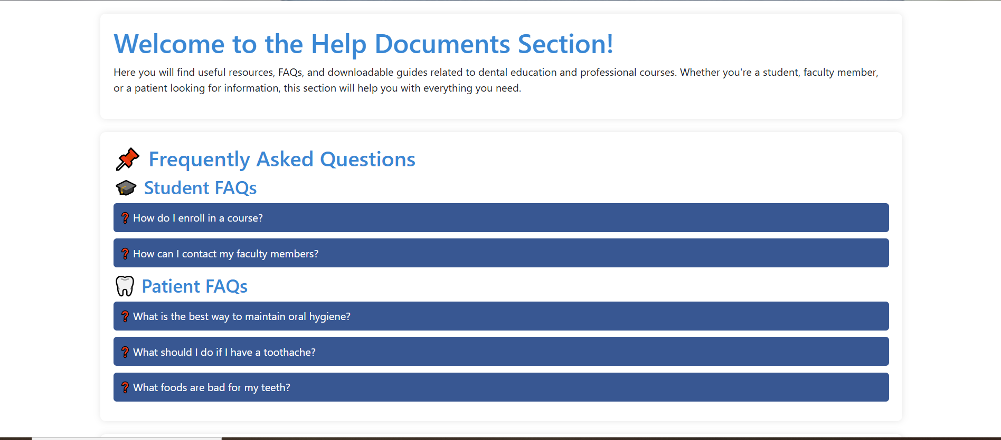

Student Resources:
The Student Resources page provides a well-organized collection of study materials, including PDFs, case studies, and educational videos. With six detailed resource cards and embedded YouTube links, it enhances learning by offering diverse content. The page also features an FAQ section to address common queries, ensuring students have easy access to essential academic support.
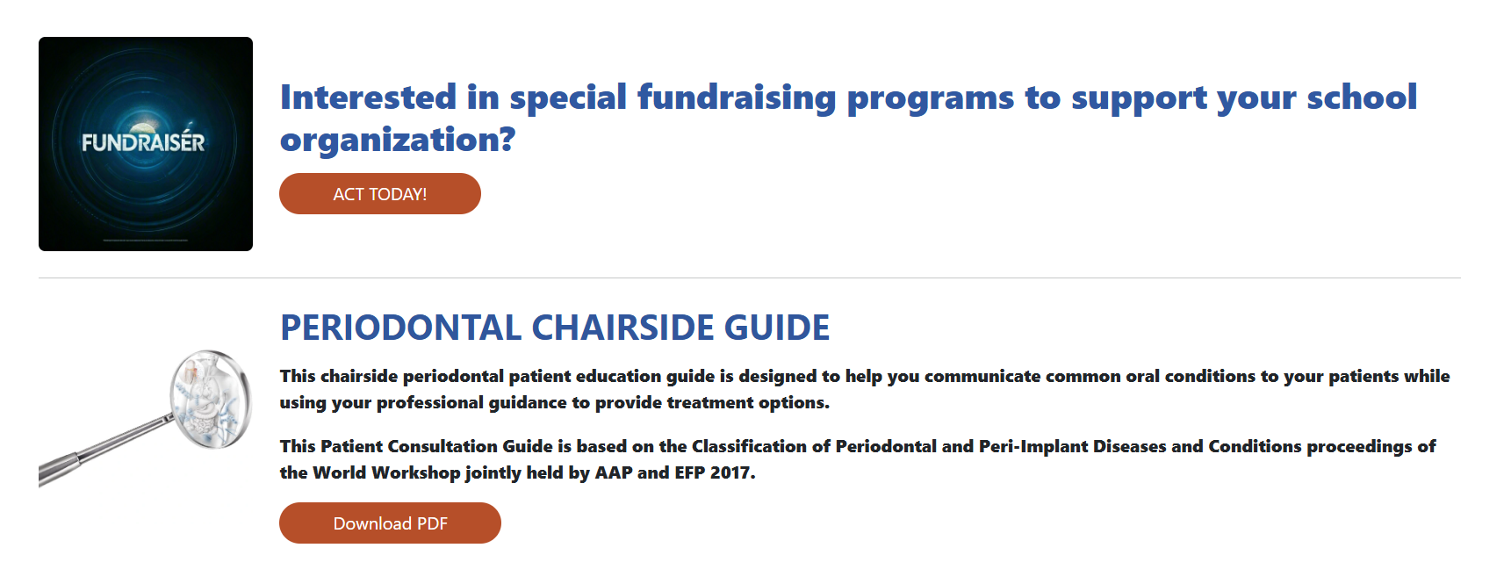

1.3 Patient Education:
The Patient Education page offers valuable dental health information through a structured layout, combining images, content, and downloadable PDFs. It begins with an introduction, followed by informative sections with images and text, providing clear insights into various dental conditions and treatments. The page also includes resource cards with PDFs and an FAQ section to address common patient concerns.

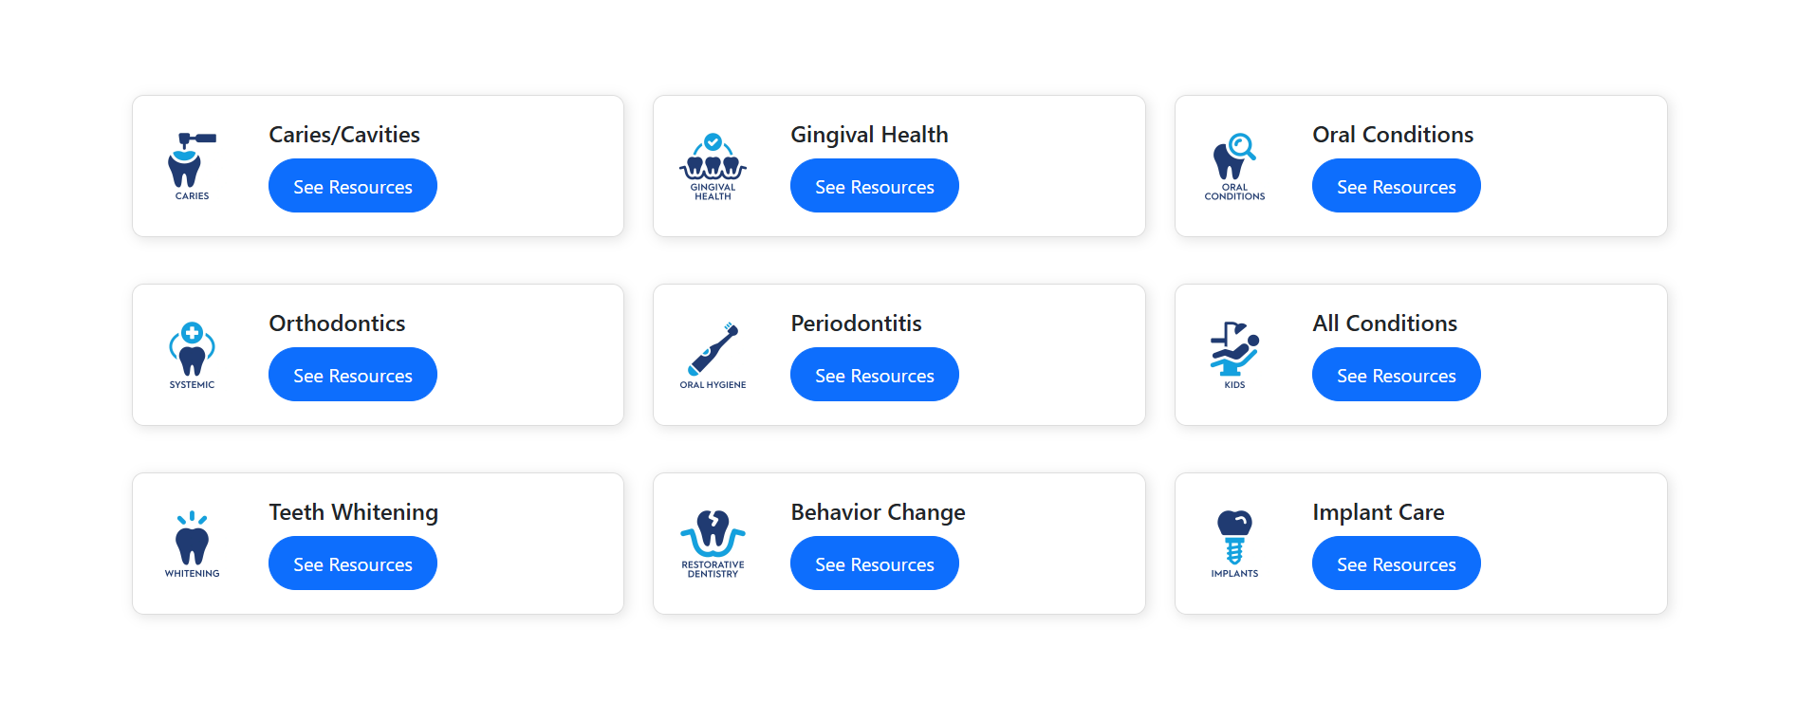

1.4 Research:
The Research page is designed to provide valuable insights into the latest developments in dentistry. It includes Latest Research, which highlights new studies and innovations, Media Library, featuring educational content for in-depth learning, and Case Studies, offering downloadable PDFs with real-world patient scenarios to enhance clinical knowledge.

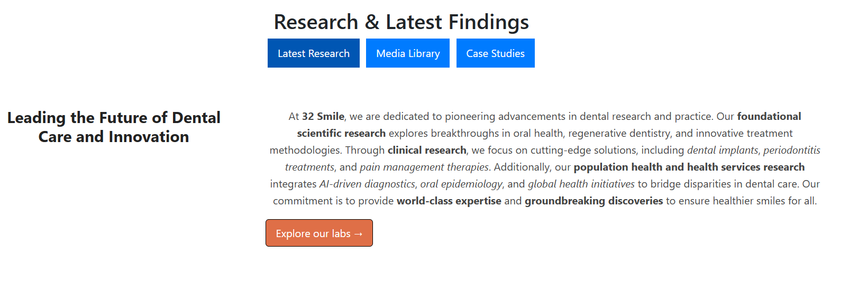

1.5 Products:
The Products page showcases a variety of dental care essentials, categorized for easy browsing. It includes Toothbrushes, featuring manual and advanced designs, Toothpastes, offering options for different dental needs, Electrical Devices, such as electric toothbrushes and oral irrigators, and Child Care Products, ensuring specialized care for young smiles.
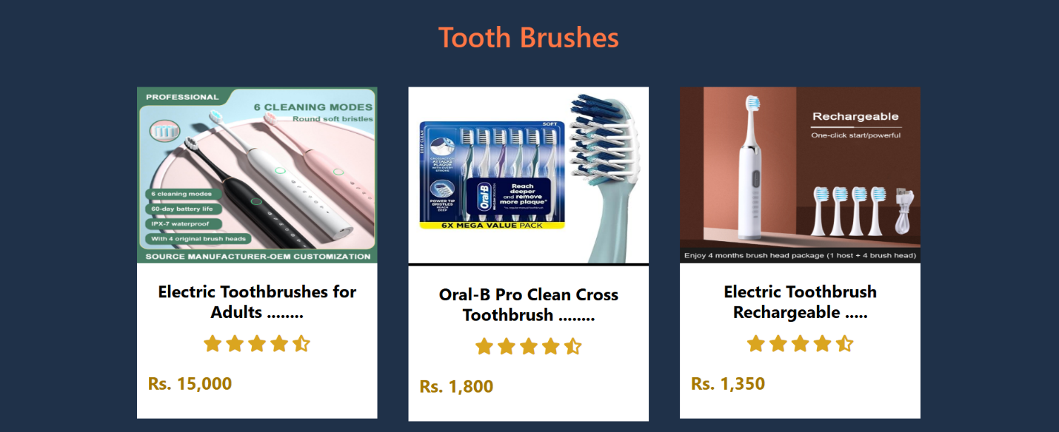

1.6 Site Map:
The Site Map page provides a structured overview of the entire 32 Smiles website, ensuring easy navigation and accessibility. It begins with an introduction explaining the site's organization, followed by a comprehensive list of links to all main pages. Each section includes a brief description with a direct link, allowing users to quickly access relevant content. This layout enhances user experience and improves SEO by offering a clear and efficient browsing structure.

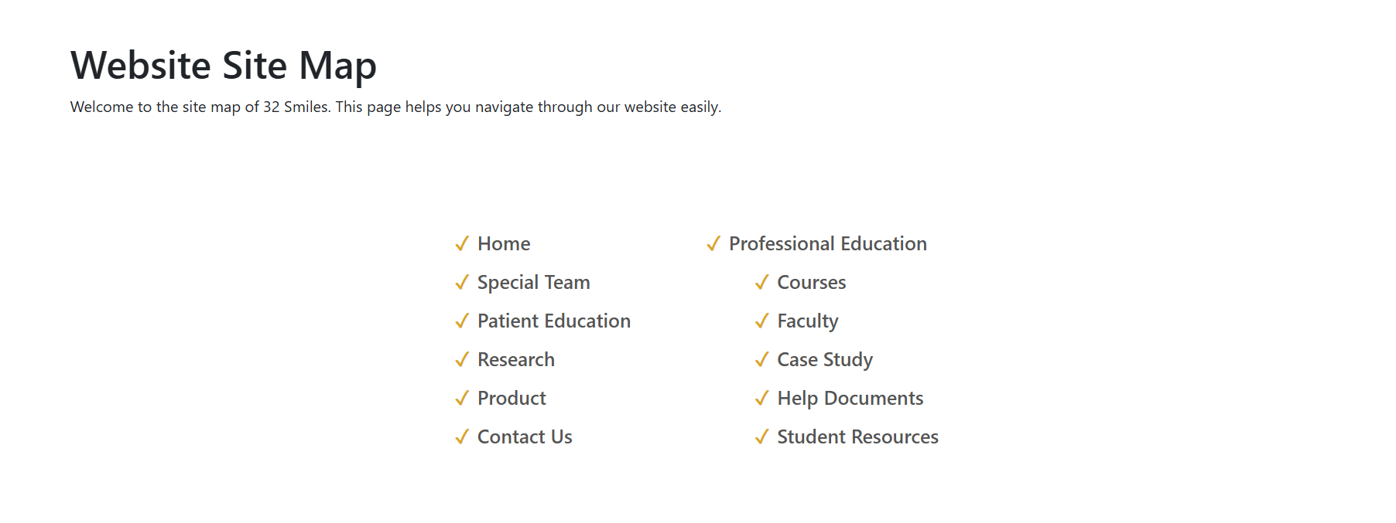
1.7 Contact:
The Contact Us page provides an easy way for users to connect with dental professionals. It features a sidebar with an interactive map for location guidance, followed by a contact form where users can submit inquiries. This structured layout ensures seamless communication and accessibility for patients, students, and professionals.

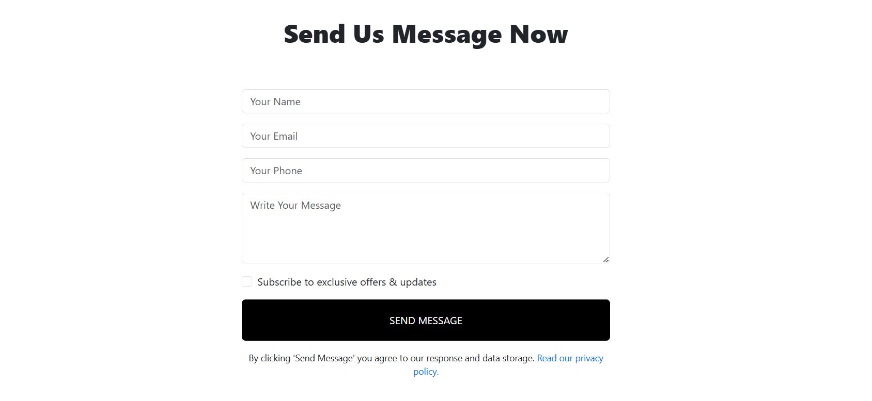

Screen Shot

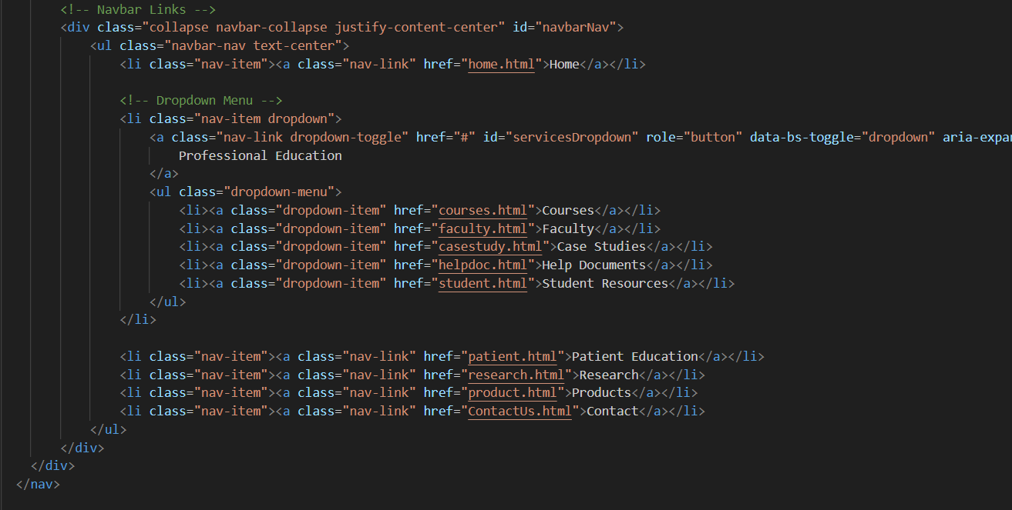
Coding

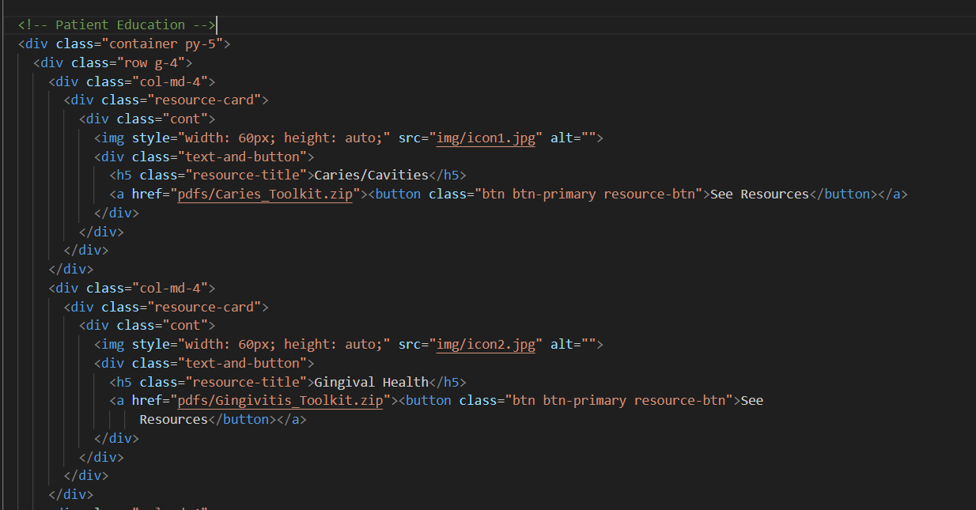
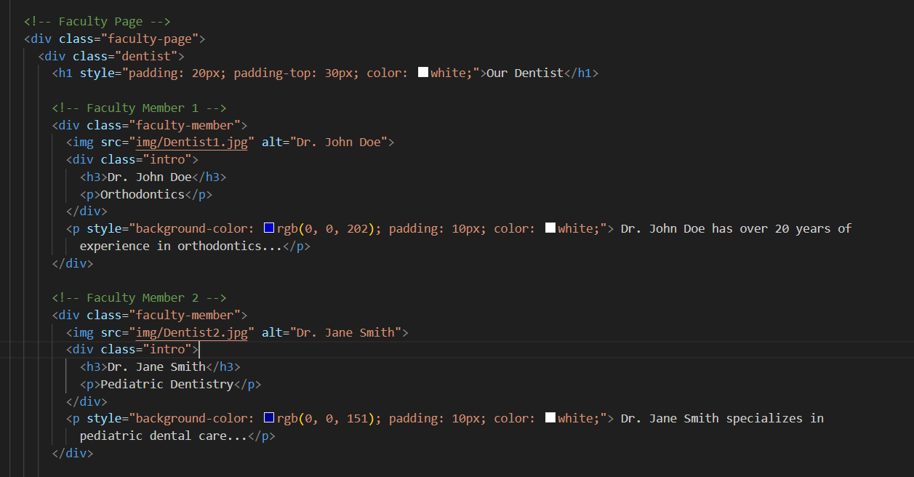

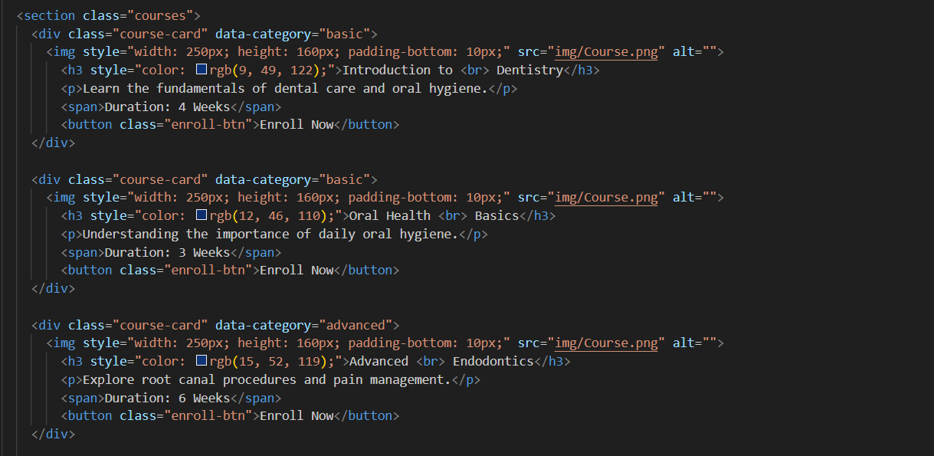

Conclusion:
The 32 Smiles website is a well-structured and user-friendly platform designed to provide valuable resources for dental students, professionals, and patients. With its organized layout, educational content, and responsive design, the website ensures easy access to case studies, research materials, patient education, and dental products. By integrating clear navigation, downloadable resources, and interactive elements, 32 Smiles serves as a comprehensive hub for dental knowledge. Future enhancements, such as more interactive features and expanded content, will further improve its effectiveness and accessibility.

DEVOLPERS GUIDE
Student Name ROLE Contribution in Project
Owais | Leader | 40%
Fahad | Member | 40%
Hassan | Member | 20%
Mustafa | Member | 0%
Huzaifa | Member | 0%

THANKYOU

